When multiple users are assigned to a single operation (Assignment type = 4) and any one user completes the operation and sync to SAP, the completed status is set for all users assigned to the same operation.
MobileStatus

/home/user/projects/SAPAssetManager/Rules/MobileStatus/CompleteMobileStatusAction.js

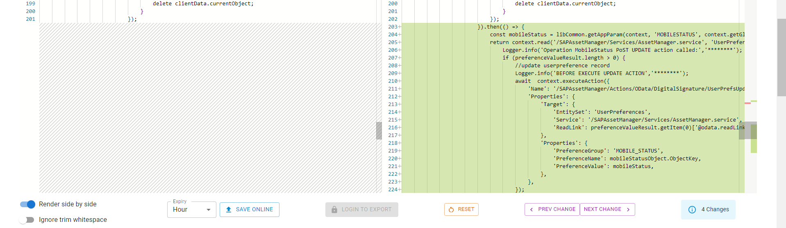

/home/user/projects/SAPAssetManager/Rules/MobileStatus/MobileStatusLibrary.js

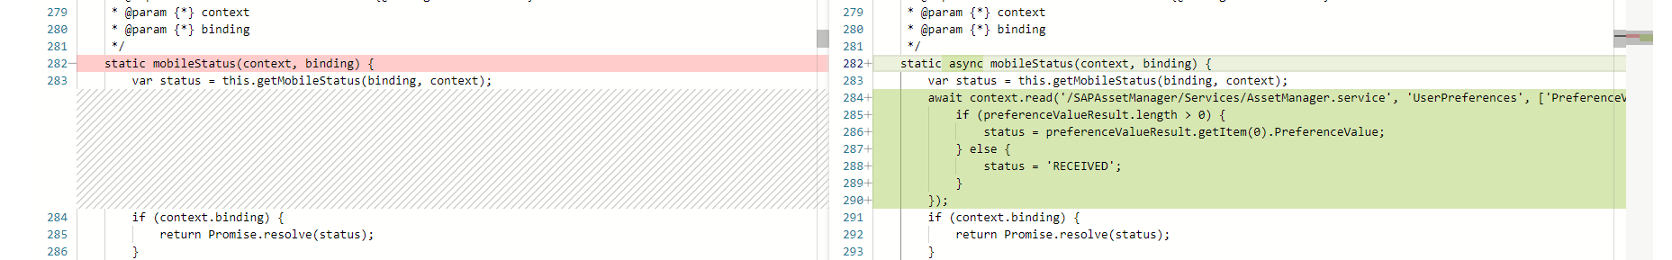

/home/user/projects/SAPAssetManager/Rules/MobileStatus/OperationMobileStatusPostUpdate.js

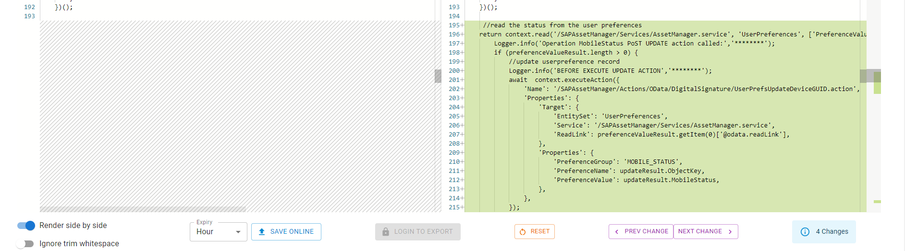

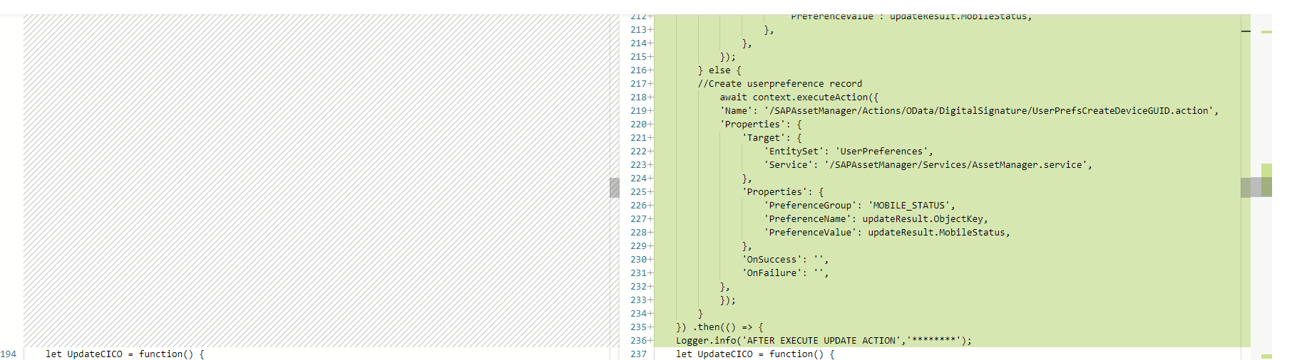
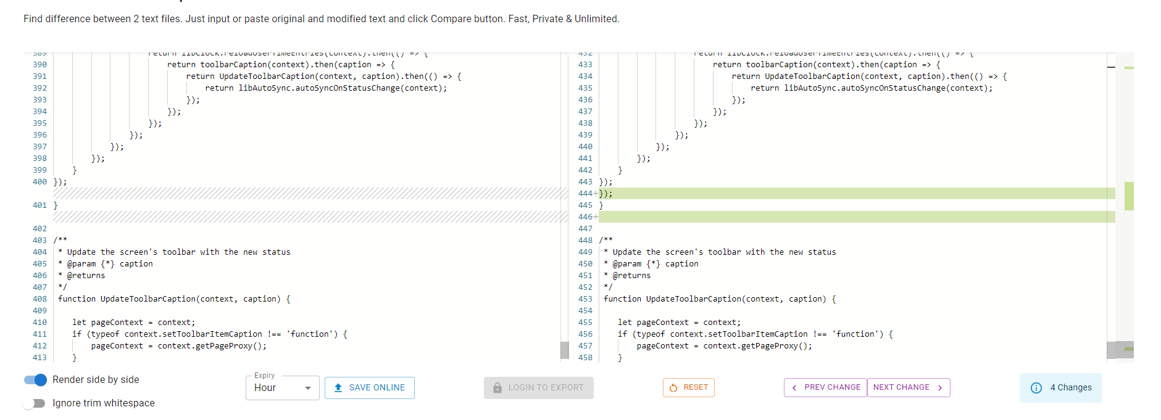

Operations
/home/user/projects/SAPAssetManager/Rules/Operations/OperationDetailsObjectHeaderTags.js
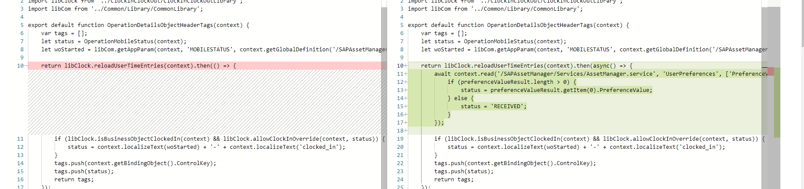

Operations/MobileStatus
/home/user/projects/SAPAssetManager/Rules/Operations/MobileStatus/OperationChangeStatusPopover
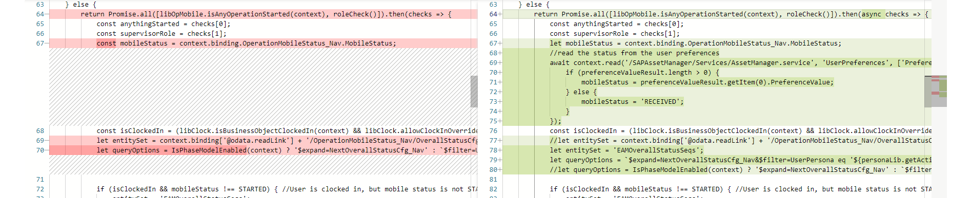
/home/user/projects/SAPAssetManager/Rules/Operations/MobileStatus/OperationEnableMobileStatus
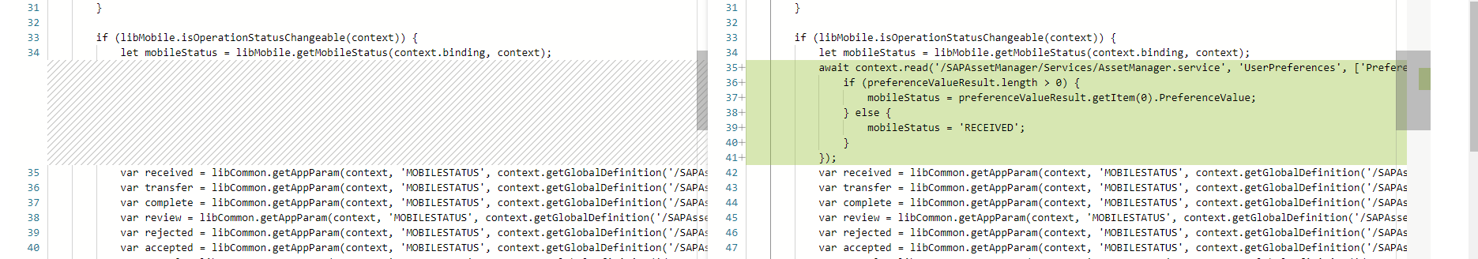
/home/user/projects/SAPAssetManager/Rules/Operations/MobileStatus/OperationMobileStatusLibrary.js
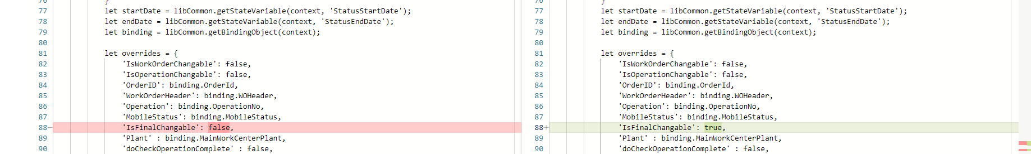

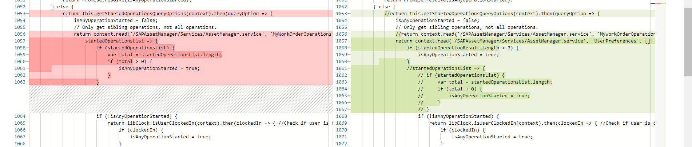

/home/user/projects/SAPAssetManager/Rules/Operations/MobileStatus/OperationMobileStatusToolBarCaption.js
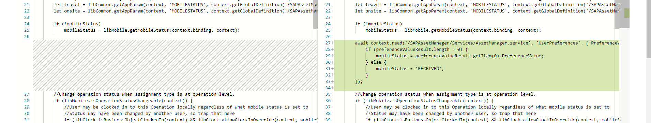

WorkOrder
/home/user/projects/SAPAssetManager/Rules/WorkOrders/WorkOrderLibrary.js

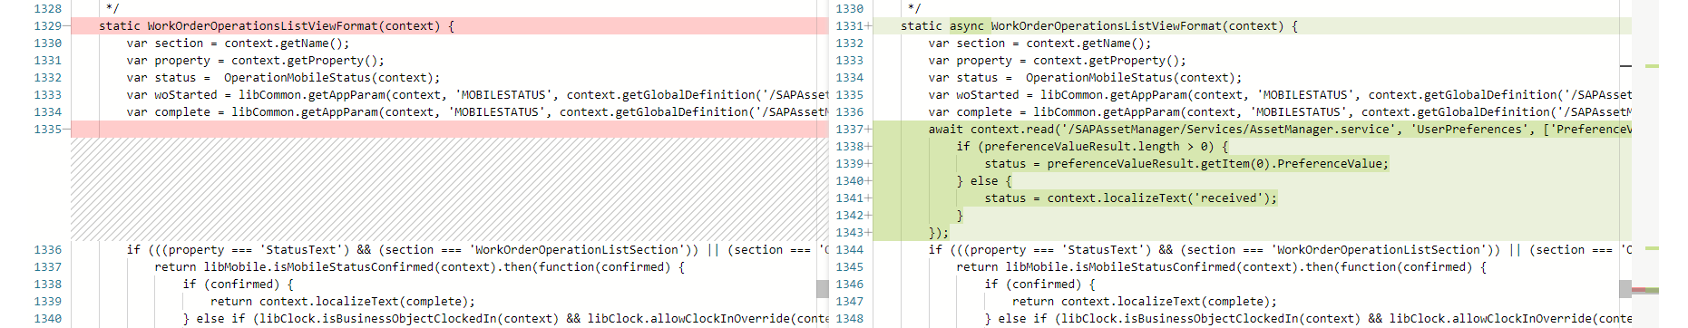
Action
New action added in Actions\OData\DigitalSignature\ UserPrefsUpdateDeviceGUID.action

